
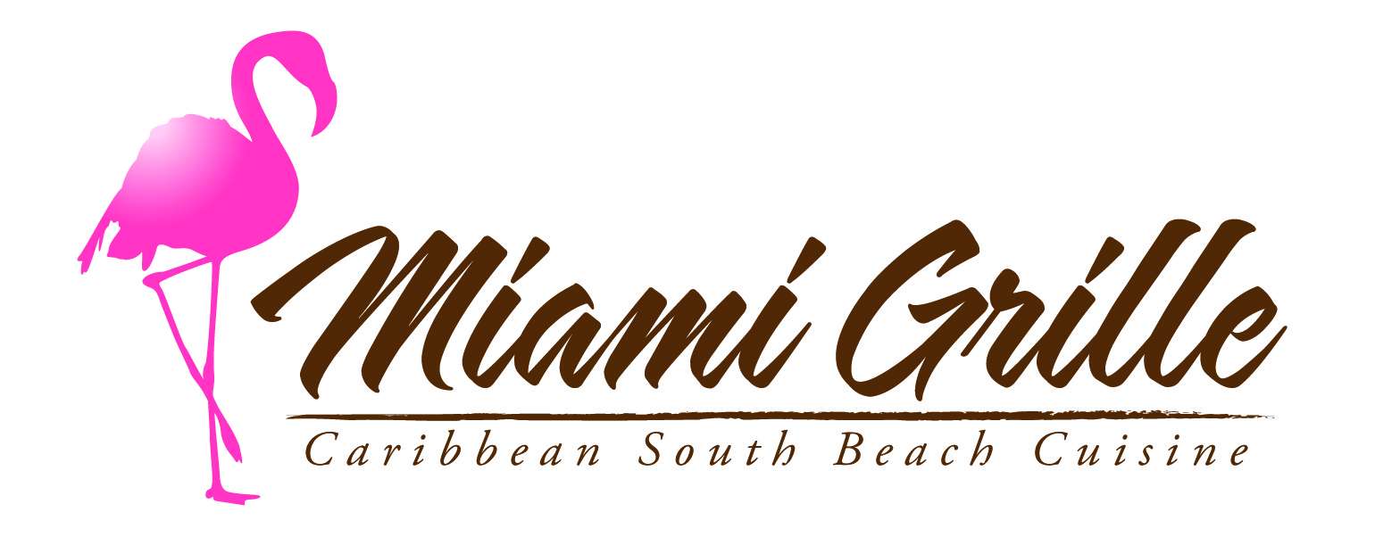
Join Us At
Tonight, Saturday, October 17 we are proud to sponsor
The San Diego Breast Cancer 3Day Camp Logistics Team!

For each of the following select items ordered tonight,
Miami Grille will donate $1 to the
Susan G. Komen Breast Cancer Foundation:
Canasta de Frita
Key West Chopp
Bread Pudding

From the bar:
Pink Ribbon Cachaça Spritzer

The event will also feature a Salsa lesson at 7pm, live Cuban band and dancing at 8pm and Raffle prizes all night!

